Stiften Donation Dapp
Aman Sharma & Aanchal Giri
#Department of Computer Science & Information Technology
ABES Engineering College, NH-24 highway, Ghaziabad, U.P., India
aman.18bci1024@abes.ac.in

#Department of Computer Science & Information Technology
ABES Engineering College, NH-24 highway, Ghaziabad, U.P., India
aanchal.18bci1007@abes.ac.in

Abstract— This paper discusses the project implementation of a donation dapp (decentralised) that can accept payment done through both medium that is crypto currency and normal indian currency. It is made to be ease the work for the good donors, they won’t be needed to find the organisation from different corners of the world. Instead they will have the list of organisation from all the places. It will help in gaining trust of customers (donors). It will be supporting donations in both Indian currency via Razorpay payment gateway and in crypto currency both.

Keywords— donations, donor’s trust, block chain, organisations, rating system for organisations
- Introduction
We are making a donation Dapp based on react and solidity. It will help in gaining trust of customers (donors). It will be supporting donations in both Indian currency via Razorpay payment gateway and in crypto currency both.
In today’s world nothing can be trusted blindly and the good donors don’t have enough time to do the background check for all the organisations so what we do all the work for them already. We will have a personal curated list for those good donors so that they don’t have to waste their time checking the background for the organisation that wether it is fake or real. In any case they know how is the organisation, they can rate and comment about that organisation. The list will be shown to him according to their location.
The organisations details will be provided along with list. The details will have the organisation name, address and the nearest site where they provide the services so that if you want then you can go there and watch things for yourself. It will also be containing a slideshow of the images.
Once a customer get him verified on the app. He will be allowed to become the active volunteer for the organisation. He will be provided with the contact within the app so that he can talk to them and ask them where is the nearest site for him to help.
If there is no site near to his place or not in his city, and there is a place where help is needed he can apply for the new site for that city and he will be needed to wait to get verified. Verification will be done on the basis of number the applications for that particular site.
- LITERATURE REVIEW
It will have two sides

- Customers side
- Admin side
- Organisation Side

Dapp will be created on the express.js and next.js on the top of solidity. Frontend will be done on the flat Next.js framework and backend will be done on the Solidity and Express.js framework. For this app to be connected to the database we will use MongoDB and solidity. MongoDB will be used for the authentication purposes mostly on the other side solidity will be used to do all the transactions of crypto currency and list of organisations will be saved in block chain server. At the end this application will be converted into PWA from js html and css for the use in mobile phones
- METHODOLOGY
In admin side there will an organization adding page where many organizations can get approved and get registered and there will be a page showing number of donation by each customer and to which organization it is made.

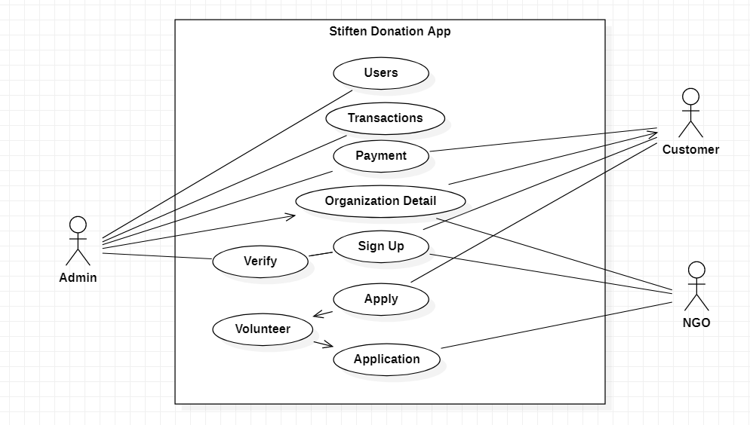
Figure 1: Use Case Diagram
In client side there will be organization page where customer can choose which organization to pay and there will be page to see the details of that organization that where are recent transaction were made by that organization. There will be payment page where there will be two options given to customer that which type of payment customer wants in crypto or in Indian currency then it will be forwarded to payment gateway

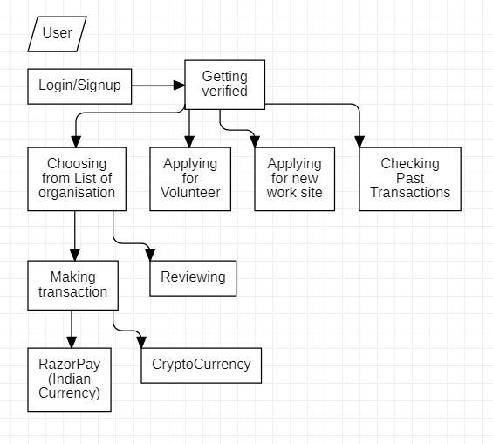
Figure 2: Flow Diagram for the Client Side of Application

